Setup OpenDS for CONNECT UC GUI Login
Overview
OpenDS, an open source directory service project, is used as a central repository for user information and provides access to user data via the LDAPv3 protocol. Working in conjunction with OpenSSO, OpenDS provides authentication services to the CONNECTUniversalClientGUI and ConsumerPreferencesProfileGUI applications by enforcing Single Sign-On (SSO) access control.
Install and Configure OpenDS
The following instructions demonstrate how to install and configure OpenDS v2.2.1 on a Windows based machine:

- In the \ThirdParty\OpenDS\Install Files directory, locate the OpenDS-2.2.1.zip file. Using a file compression utility like 7zip, unzip the file to the C:\ directory. The following directory should now exist on your computer:
C:\OpenDS-2.2.1
- Launch a new command window, navigate to the C:\OpenDS-2.2.1 directory, and run the following command:
setup –cli
The OpenDS Directory Server QuickSetup window will display after the following output is displayed:
Launching graphical setup…
- From the welcome screen, click the “Next >” button:

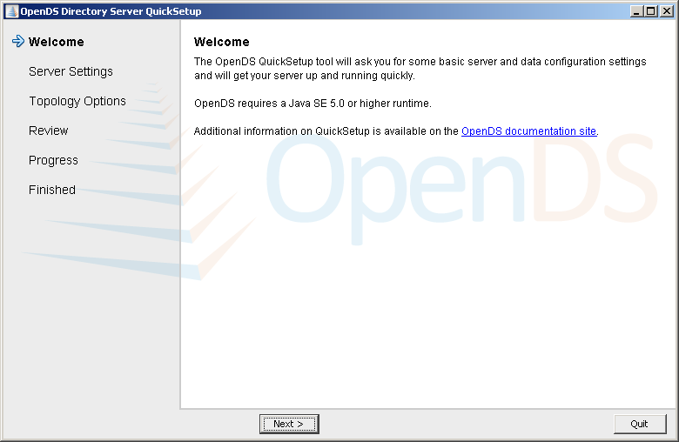

- Change the “Host Name” setting to “localhost”, enter a Password of “adminadmin” and then click the “Next >” button:
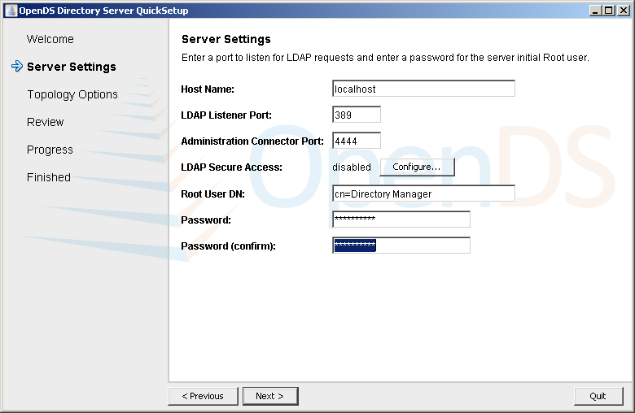
- Choose the “This will be a standalone server” option and then click the “Next >” button:
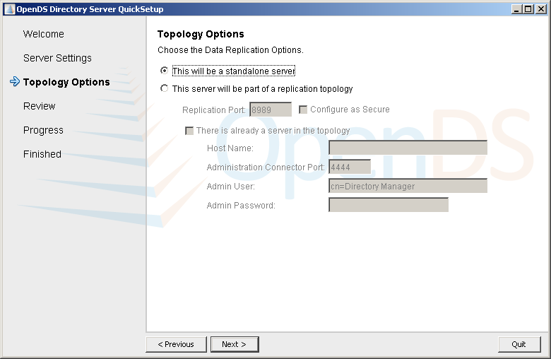
- Enter a “Directory Base DN” value of dc=opensso,dc=java,dc=net and then click the “Next >” button:

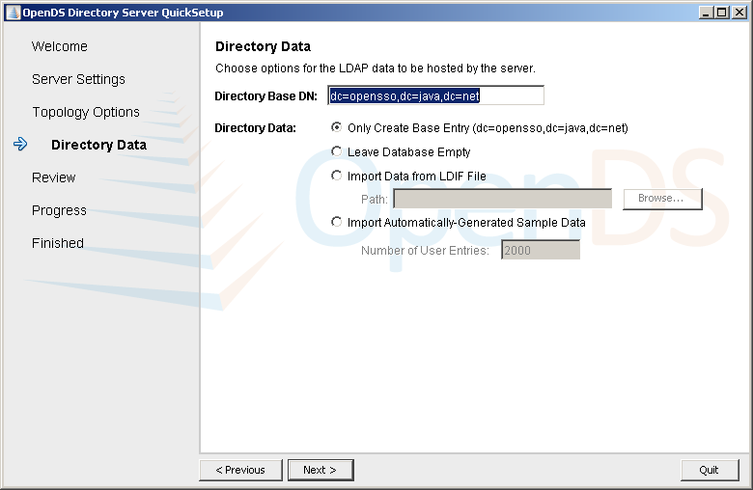

- For installation on a production server, check the “Run the server as a Windows Service” checkbox. Otherwise, the this checkbox can remain unchecked (and OpenDS will be started and stopped via command line). Click the “Finish” button:
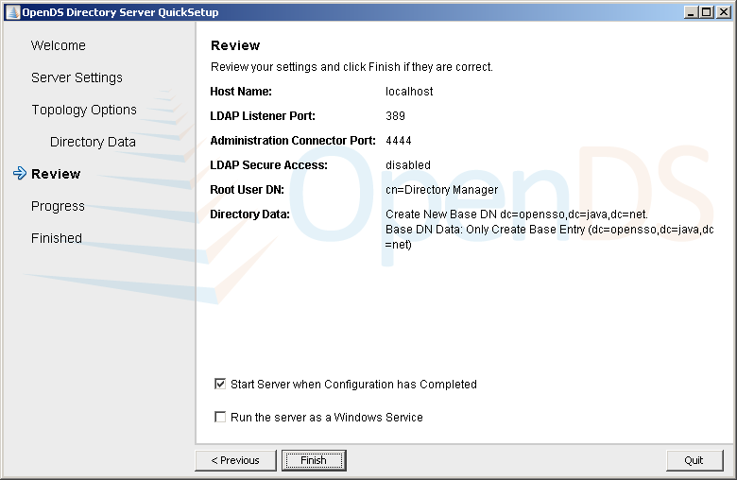
- At this point, the progress of your install will be displayed. Successful installation of OpenDS will result in the following window being displayed:
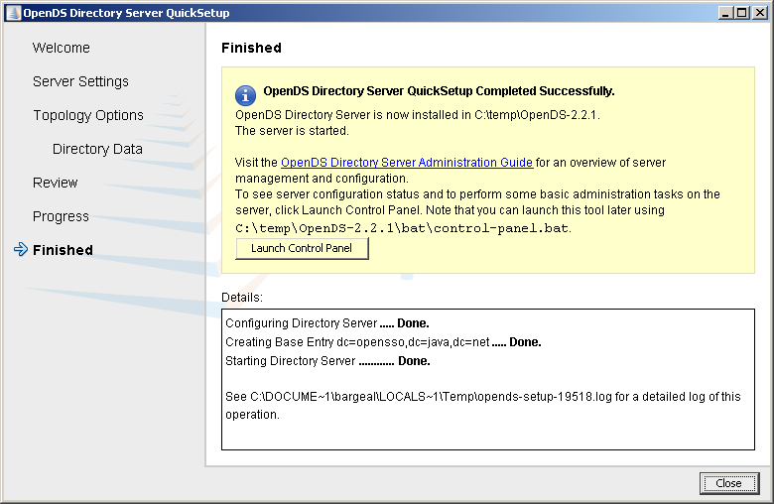
The above sequence of steps results in the installation of an OpenDS server with the suffix dc=opensso,dc=java,dc=net.
Preparing OpenDS to be used with OpenSSO
The steps outlined below will prepare OpenDS to be used as a Data Store within OpenSSO. OpenSSO does not need to be operational in order to perform the following steps:
- Navigate to the \Projects\NHINC\3.1\ThridParty\OpenDS\Install_Files directory and ensure it contains a file called “midht_am_remote_opends_schema.ldif”.

- Open a command prompt, navigate to the C:\OpenDS-2.2.1\bat directory and run the following command:
ldapmodify -h localhost -p 389 -D "cn=Directory Manager" -w adminadmin -c -f D:\Projects\NHINC\3.1\ThirdParty\OpenDS\Install_Files\midht_am_remote_opends_schema.ldif
If successful, you should see output similar to the following:
Processing MODIFY request for cn=schema
MODIFY operation successful for DN cn=schema
- Navigate to the Projects\NHINC\3.1\ThridParty\OpenDS\Install_Files directory and ensure it contains a file named “midht_configure_opends_userstore.ldif”.

- From the command prompt, navigate to the C:\OpenDS-2.2.1\bat directory and run the following command:
ldapmodify -h localhost -p 389 -D "cn=Directory Manager" –w adminadmin -c -a -f D:\Projects\NHINC\3.1\ThirdParty\OpenDS\Install_Files\midht_configure_opends_userstore.ldif
If successful, you should see output similar to the following:
C:\OpenDS-2.2.1\bat>ldapmodify -h localhost -p 389 -D "cn=Directory Manager" -w
adminadmin -c -a -f D:\Projects\NHINC\3.1\ThirdParty\OpenDS\Install_Files\config
ure_opends_userstore.ldif
An error occurred while attempting to open the LDIF file
D:\Projects\NHINC\3.1\ThirdParty\OpenDS\Install_Files\configure_opends_userstore
.ldif
for reading:
D:\Projects\NHINC\3.1\ThirdParty\OpenDS\Install_Files\configure_opends_userstore
.ldif
(The system cannot find the file specified)
C:\OpenDS-2.2.1\bat>ldapmodify -h localhost -p 389 -D "cn=Directory Manager" -w
adminadmin -c -a -f D:\Projects\NHINC\3.1\ThirdParty\OpenDS\Install_Files\midht_
configure_opends_userstore.ldif
Processing ADD request for ou=people,dc=opensso,dc=java,dc=net
ADD operation successful for DN ou=people,dc=opensso,dc=java,dc=net
Processing ADD request for ou=groups,dc=opensso,dc=java,dc=net
ADD operation successful for DN ou=groups,dc=opensso,dc=java,dc=net
Processing ADD request for ou=opensso adminusers,dc=opensso,dc=java,dc=net
ADD operation successful for DN ou=opensso adminusers,dc=opensso,dc=java,dc=net
Processing ADD request for cn=openssouser,ou=opensso adminusers,dc=opensso,dc=ja
va,dc=net
ADD operation successful for DN cn=openssouser,ou=opensso adminusers,dc=opensso,
dc=java,dc=net
Processing MODIFY request for cn=openssouser,ou=opensso adminusers,dc=opensso,dc
=java,dc=net
MODIFY operation successful for DN cn=openssouser,ou=opensso adminusers,dc=opens
so,dc=java,dc=net
Processing ADD request for cn=ldapuser,ou=opensso adminusers,dc=opensso,dc=java,
dc=net
ADD operation successful for DN cn=ldapuser,ou=opensso adminusers,dc=opensso,dc=
java,dc=net
Processing ADD request for cn=user2@testopends.com,ou=people,dc=opensso,dc=java,
dc=net
ADD operation successful for DN cn=user2@testopends.com,ou=people,dc=opensso,dc=
java,dc=net
Processing ADD request for ou=roles,dc=opensso,dc=java,dc=net
ADD operation successful for DN ou=roles,dc=opensso,dc=java,dc=net
Processing ADD request for ou=physician,ou=roles,dc=opensso,dc=java,dc=net
ADD operation successful for DN ou=physician,ou=roles,dc=opensso,dc=java,dc=net
Processing ADD request for cn=nicu.physician,ou=physician,ou=roles,dc=opensso,dc
=java,dc=net
ADD operation successful for DN cn=nicu.physician,ou=physician,ou=roles,dc=opens
so,dc=java,dc=net
Processing MODIFY request for dc=opensso,dc=java,dc=net
MODIFY operation successful for DN dc=opensso,dc=java,dc=net
Processing MODIFY request for dc=opensso,dc=java,dc=net
MODIFY operation successful for DN dc=opensso,dc=java,dc=net
Processing MODIFY request for dc=opensso,dc=java,dc=net
MODIFY operation successful for DN dc=opensso,dc=java,dc=net
Processing MODIFY request for dc=opensso,dc=java,dc=net
MODIFY operation successful for DN dc=opensso,dc=java,dc=net
- The OpenDS Referential Integrity Plugin is not enabled by default and needs to be installed in order to ensure that when groups are removed from the directory – all of its connections to the users entries are automatically removed. To install this plugin, navigate to the C:\OpenDS-2.2.1\bat directory and run the following command:

dsconfig -h localhost -p 4444 -D "cn=Directory Manager" -w adminadmin -n set-plugin-prop --plugin-name "Referential Integrity" --set enabled:true --trustAll

If successful, you will be returned to the command prompt without error messages.

The OpenDS installation for the MIDHT project is now complete. To verify the above steps were performed correctly, use the OpenDS control panel to verify that a test user, User Two, exists in the LDAP repository.

To start the control panel, type “control-panel” from the C:\OpenDS-2.2.1\bat directory command line. Once you’ve successfully logged-in to the control panel, click the “Manage Entries” option on the left-hand menu and then expand the “people” branch of the tree that has the root of “dc=opensso, dc=java, dc=net”. You should now see a test person named “user2@testopends.com”. If you click on the user’s name, you should see information similar to the information in the following screen shot:

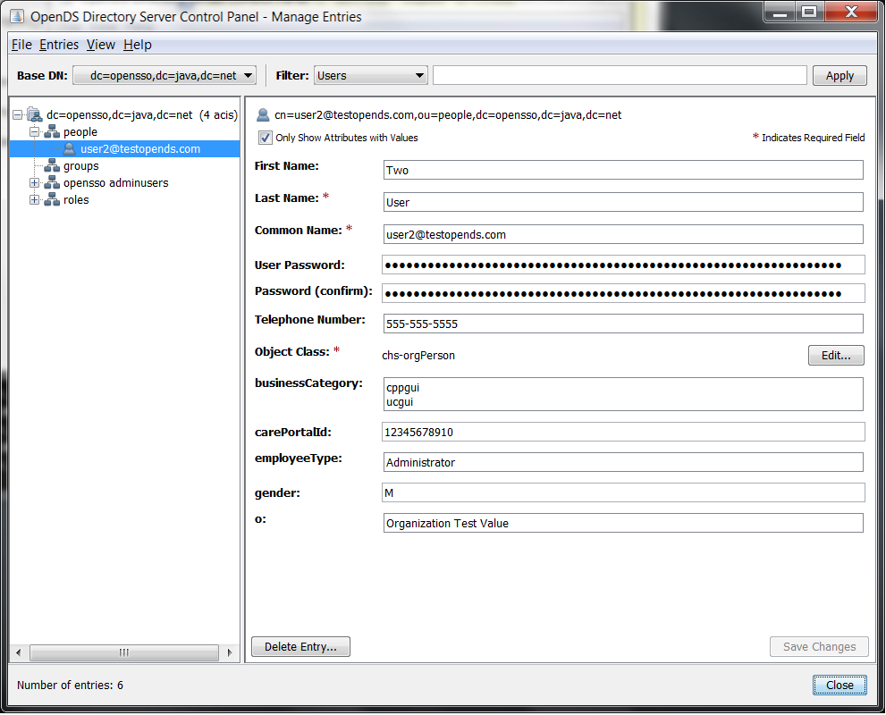

You are now ready to install and configure OpenSSO for use with your newly created OpenDS Directory Server. Please follow the MIDHT OpenSSO installation and configuration guide for further instructions.

Create an OpenDS Data Store in OpenSSO
The steps outlined below create an LDAP v3 data store within OpenDS that points to the OpenDS instance that was configured in the preceding steps.

- Navigate to the C:\NHINC\ThirdPartyTools\OpenSSO\ssoAdminTools\opensso\bin directory

- Using the “datastore_opends_attrs.txt” file that is bundled with this documentation and run the following command (be sure to replace <txt file location> with the actual location of the .txt file:
ssoadm create-datastore -m "OpenDS User Store" -t "LDAPv3" –D <txt file location>\datastore_opends_attrs.txt -u amadmin -f C:\NHINC\ThirdPartyTools\OpenSSOXACMLExample\password.txt -e /
If successful, you should see the following output:
Datastore was created.
- At this point, the default OpenSSO User Store can be removed by following these steps:

  - Open a web browser, navigate to https://localhost:2080/opensso , and login as amadin
  - From the “Common Tasks” screen, click the “Access Control” tab
  - Select “/ Top Level Realm” from the list of realms
  - Select the “Data Stores” tab
  - Check the checkbox next to all Data Stores that are not named “OpenDs User Store” and then press the “Delete” button.
  - Ensure that the only Data Store that’s listed is called “OpenDs User Store”
You have now successfully completed creating an OpenDS Data Store within OpenSSO.
Create OpenDS Users via OpenSSO
The steps outlined below create users, via the OpenSSO interface, that get stored in the OpenDS directory service. The users then can be used to allow/deny permission to the MIDHT UniversalClient GUI and CPP GUI.
- Open a web browser, navigate to https://localhost:2080/opensso , and login as amadmin
- From the “Common Tasks” screen, click the “Access Control” tab
- Select “/ Top Level Realm” from the list of realms
- Select the “Subjects” Tab
- Click the “New…” button
- On the new user screen, fill in the appropriate user information and ensure the “User Status” is set to “Active”

- Click the “OK” button in the top right-hand corner of the screen
- Ensure newly created user is listed in the “Users” table that appears on the “Subjects” screen.

- At this point, a newly created user has successfully been added to OpenDS. To test whether or not the user account will be able to login to the MIDHT GUI’s, follow these steps:

  - Navigate to the C:\NHINC\ThirdPartyTools\OpenSSOXACMLExample directory and run the following command:
scripts\Login
You will now be presented with a series of prompts.
  - When prompted to enter a realm - Realm (e.g. /) : , press Enter
  - For Login module name - Login module name (e.g. DataStore or LDAP): , type “DataStore” then press Enter
  - For Login locale - Login locale (e.g. en_US or fr_FR): , type “en_US” then press Enter
  - For User Name and Password, enter the username and password that was created in the preceding steps. If Login is successful, the following will be shown in the command window:
Login succeeded.
Logged Out!!
If login succeeded, you now should be able to use the user account to successfully log into the MIDHT GUI’s.

